**FINAL REPORT**

**HOSPITAL DATABASE**

A hospital is a very busy place and it is tough for the hospital to maintain its day to day activities and records manually. The purpose of this document is to give a report on a hospital database system that keeps and manages records of all type of activities of a hospital.

**AUTHOR IDENTIFICATION**

Name: Nur Tariqur Email: [tnur16@winona.edu](mailto:tnur16@winona.edu)

Name: Masha M. Stephen Email: Stephen.masha@go.winona.edu

**ROLES EACH TEAM MEMBER PLAYED**

**SUMMARY OF THE PROJECT**

* **Motivation**

Hospitals make crucial decisions on life, patients and the kind of service that they need. We wanted a database that has all the activities and roles of all the people taking part in transactions and day to day activities in the hospital. Only people with access to the hospital can view and use the database.

* **Scope**

This system is a relational database with tables such as: nurse, physicians, department, hospital, prescribes, rooms, medication, takes and patient. The database will support a chain of all the different departments of the hospital and patients from all over the world. We hope to simplify the work that doctors do in order to keep track and give proper care to all the patients.

* **Conclusion**

The database has been organized and written in MySQL so to access its content; one will need to use SQL language. Only people with authorization can access the records. Patients only fill forms that are applicable to them while doctors put the patient’s information on their end of what they can view. Doctors can view and share information of a patient if the patient aggress to the information to be shared and this is only for medical purposes. This preserves doctor patient confidentiality.

**DATA**

When developing a prototype, having data to test it is essential. We could not get real word data, so we relied on realistic but generated data. We wanted data that would match something close to what the real world would have provided so we used Mockaroo. This site enabled us to generate clean data which was helpful during the testing phase of our database. The reason as to why we chose Mockaroo is that it allows you to quickly and easily make random generated test data that suits your database and you can easily download the data to add to MySQL.

**DESIGN**

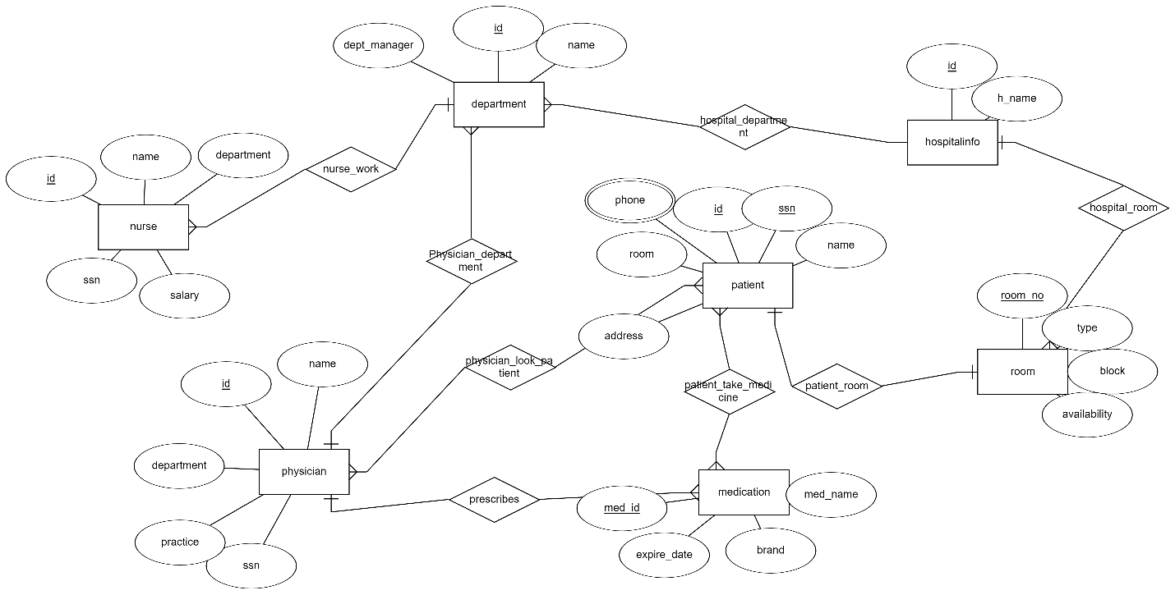

Tables for the database:

1. Departments (id, name, dept_manager)
2. Physician (id, name, practice, ssn, department)

3.Patient (SSN, name, address, phone, id, room)

4. Nurse (id, name, SSN, salary, department)

1. Medication (med_id, med_name, brand, expire_date)
2. Room (room_no, type, block, availability)
3. Hospitalinfo (id, h_name)
4. Nurse_work( d.id, n.id)
5. Hospital_department( h_id, d_id)
6. Patient_room( p_id, r_id, room_no)
7. Prescribes (p_id, med_id)
8. Phsycian_look_patient (patient_id, p_id)
9. Patient_takes_medicine (p_id, m_id)